The Buzz about Bees
(English, form 7-8)

Teacher’s Worksheet

Name: ____________________________________________________________

Today, our English lesson is not in a classroom, but here, in the wonderful Museum of Beekeeping! We are going to become real researchers!

We will explore the secret world of insects. Did you know that bees communicate with their “dances”? We will find out how! We will also find out how scientists give Latin names to insects, how the physics of a bee’s flight inspired (= вдохновила) a famous writer, and understand why beehives have changed over history.

We will work with museum exhibits and complete 9 short tasks. Each task is a small discovery. Let's start our adventure!

Task 1. True or False? (Knowledge and Intuition)

Read the facts about insects below. Write T (True) if you think the fact is correct, or F (False) if you think it is wrong. Use your general knowledge and intuition!

- A bee has five eyes. (_____)
- All insects have 8 legs. (_____)
- An insect’s skeleton is on the outside of its body. (_____)
- Butterflies taste their food with their feet. (_____)
- Mosquitoes are the deadliest animals in the world for humans. (_____)

Answers:

- T (They have 2 large compound eyes and 3 simple eyes).
- F (Insects have 6 legs, spiders have 8).
- T (This is called an exoskeleton).
- T (This is a real fact!).
- T (Mosquitoes carry malaria, dengue, etc., which kill about 700 000 – 1 000 000 people a year).

Task 2. The Language of Science (Taxonomy)

Taxonomy [tækˈsɒnəmɪ] (= таксоно́мия) is the study of the general rules of scientific classification. In biology, all the living beings are given international Latin names which scientists all over the world understand. Look at the exhibits and the labels with Latin names. Read the rules of binomial nomenclature (= биноминальная номенклатура) and complete the tasks.

Rules:
- Binomial nomenclature [baɪˈnoʊmiəl ˌnoʊˈmɛnkleɪtʃər] (two-word names) is used for all living organisms.
- The first word (e.g., Bombus) is the genus [ˈʤiːnəs] (= родовое название). It is always capitalized.
- The second word (e.g., terrestris) is the species [ˈspiːʃiːz] (= видовое название). It is always written in lower case.
- The whole name must be written in italics.

Part A: Match the Latin names with their full or partial translations. Use your logic, work in groups!

Latin Name (Genus + Species) | Meaning / Translation
1. Apis mellifera (honey bee, медоносная пчела) | A. “Giant”
2. Bombus terrestris (buff-tailed bumblebee, большой земляной шмель) | B. “Bee” + “honey-bearing”
3. Oryctes nasicornis (European rhinoceros beetle, жук-носорог) | C. “Butterfly” + “named after the scientist Maack”
4. Blaberus giganteus (giant cockroach, гигантский лесной таракан) | D. “Nose” + “horn”
5. Papilio maackii (Alpine black swallowtail, парусник Маака) | E. “Earth” + “living”

1 - ____B, 2 - ____E, 3 - ____D, 4 - ____A, 5 -____C.

Part B (optional): Now, read the labels carefully. Find two more insects with “speaking” Latin names and write them down.
Latin name: ______________________ (meaning: ______________________)
Latin name: ______________________ (meaning: ______________________)

Task 3. Insect Anatomy (Reading & Labeling)

Look at the display with the insect anatomy diagram. Read the descriptions of five different organs below. Match each description with the correct English word and label the diagram.
antennae [anˈtennae] / abdomen [ˈæbdəmən] / compound [ˈkɒmpaʊnd] eyes / thorax [ˈθɔːræks] / stinger (or sting)

- This is the larger part of the bee’s body. It contains the digestive (= пищеварительная) system, the reproductive organs, and the wax glands (= восковые железы). In worker bees, this part ends with a defensive weapon. (Answer: _____________ abdomen)
- These are two large organs on the sides of the head. They help the bee see the world in a mosaic way and detect the ultraviolet light of flowers. (Answer: _____________ compound eyes)
- This is the middle part of the body. It is very strong because it holds the powerful muscles that move the wings and the legs. (Answer: _____________ thorax)
- These are moveable organs on the top of the head. The bee uses them to touch, smell, and sense vibrations in the air to navigate. (Answer: _____________ antennae)
- This is a sharp organ located at the very end of the abdomen. When the bee uses it, it injects venom to protect the hive (= улей) from enemies. (Answer: _____________ stinger, sting)
thorax
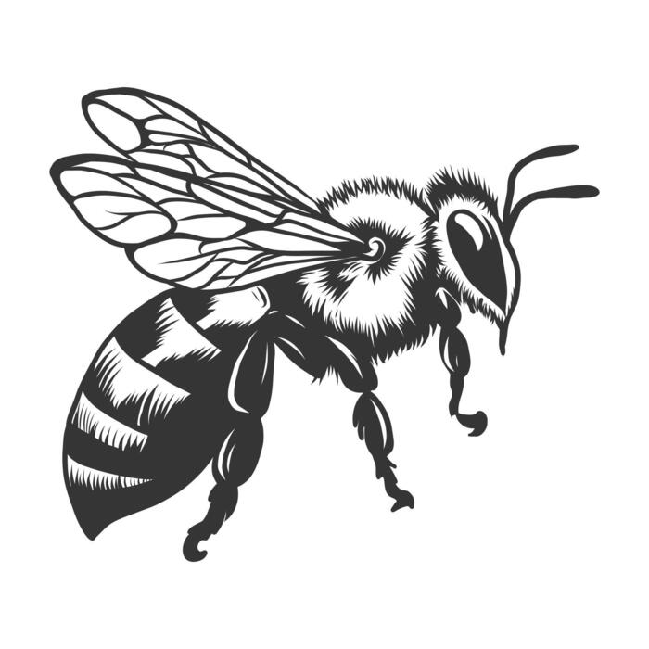
antennae

abdomen

compound eyes

stinger, sting

Task 4. Physics of Flight (Looking at the Model & Literature)

Look at the large model of a bee in the exhibition. Insects have a unique physical way of flying.

Read the text and fill in the gaps with the correct words (remember the rules of word formation).

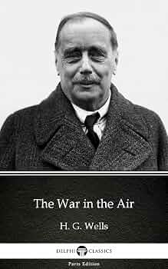
Unlike an airplane, a bee’s wings don’t just move up and down. They also move back and forth, creating tiny whirlwinds (= вихри) of air. This (MOVE) movement is very fast, which makes the bee stable in the air. The bee’s body is not built for high speed, but for excellent balance. The wings are connected to (POWER) powerful flight muscles in the thorax. When a bee flies, these muscles produce a buzzing sound. The physics of this flight is really (MYSTERY) mysterious for engineers who try to build small flying robots.
Interestingly, the famous British writer Herbert George Wells (by the way, Doctor of Biology) described a similar idea in his novel The War in the Air in 1907. His character, a British (INVENT) inventor, built a flying machine based on the anatomy of a bee. This machine could fly by making wavy movements, going up and down, (EXACT) exactly like a giant insect. Wells showed that copying nature’s flight solutions could help humans create new technology.

Task 5. Pollination (= опыление) and Symbiosis [sɪmbɪˈəʊsɪs] (Vocabulary)

In biology and chemistry, you study the interaction between plants and insects. Look at the exhibits showing insects and flowers (orchids, figs, clover). Choose the correct word (A, B, or C) to complete the sentences.

- An insect visits a flower to get nectar and _______, which is food for its larvae (= личинки).
A) wood
B) pollen (= пыльца)
C) wax
- The relationship between the fig tree and the fig wasp is a perfect example of _________, where both species benefit.
A) competition
B) symbiosis
C) predation
- Plants use bright colors and ________ to attract their pollinators.
A) sound
B) electricity
C) smell
- When a bee moves from flower to flower, it carries pollen, which is necessary for plant ___________.
A) reproduction
B) eating
C) sleeping
- In the museum display “Cheaters and thieves”, some orchids use a special trick. They don’t give nectar, but they still force insects to pollinate them. This is an example of _________ in nature.
A) a fair deal
B) a deception
C) friendship

Task 6. Bee Communication (Compared to Human)

Look at the “Bee Dances” information panel. Bees have a special way of communicating. Read the text below and find 6 grammar mistakes in it. Underline them and write the corrected version.

Bees communicate with each other through dance. A worker bee do a “waggle (= виляние) dance” (= танец пчёл) to tell the others where the food is. The direction of the dance show the angle to the sun. The speed of the dance shows how far the food are.
But bees are not the only animals which communicate in this way. Humans also use dances to communicate, but we usual speak or write. However, scientists believe that human dance may have started as a way to share informations about hunting, just like bees share information about nectar.
If a bee finds a very good flower, it dances longer and faster to say “This is a super place!”. Humans would probably just shouted “Wow!” or send a text message.

Corrected mistakes:
- ___________do -> ___________ does
- ___________show -> ___________ shows
- ___________are -> ___________ is
- ___________usual -> ___________ usually
- ___________informations -> ___________ information
- ___________shouted -> ___________ shout

Task 7. Hive Evolution (Reading and Matching)

Look at the exhibits showing different types of bee hives (the log, the wooden box, the modern frame hive, etc.). Read the definitions and match them with the correct hive type.

- The bort / log (= борть). This is a natural tree hollow. Bees build honeycombs (= соты) inside it. It is very difficult to get the honey without ______.
A) damaging the log
B) feeding the bees
- The frame hive (= рамочный улей). This invention changed beekeeping. It has wooden frames that can be moved. This allows the beekeeper to collect honey without ______.
A) destroying the honeycomb
B) using smoke
- The modern automatic hive. This is a new design. It has special tubes to get honey. This helps the beekeeper because he/she doesn't have to ______.
A) open the hive often
B) feed the queen bee
- The sapling (= сапетка). This is a very old type of hive made of straw or twigs. It looks like an upside-down basket. Beekeepers used it for centuries, but it was very difficult to clean because ______.
A) you could not remove the honeycomb without breaking it
B) bees did not like straw
- The modern plastic hive. Recently, some beekeepers have started using hives made of special plastic. This material is very light and strong. It helps bees to survive in cold winters because ______.
A) plastic produces heat
B) plastic is a good insulator (keeps warmth inside)

Answers:
- A (damaging the log – because the old log hives had to be broken to get honey).
- A (destroying the honeycomb – because you can remove the frames safely and put them back).
- A (open the hive often – because the honey is extracted via special tubes without opening the whole hive).
- A (you could not remove the honeycomb without breaking it - because the woven sapling was non-dismantable).
- B (plastic is a good insulator - plastic does not conduct heat well).

Task 8. Attention Check! (True or False?)

Now that you have finished your tour, check your attention! Are these facts true or false? Write T (True) or F (False) based on what you saw and read during the lesson.

- The yellow and black striped insect you see in the museum is an ant. (_____)
- Bees use wax to build the cells of their honeycomb. (_____)
- The museum has a special exhibit showing a “bee dance” that tells the bees where to find nectar. (_____)
- Bees are not related to wasps or ants. (_____)
- Modern beehives are made of straw and twigs. (_____)

Answers:
- F (It's a bee/wasp/bumblebee, etc., not an ant).
- T (Wax is produced by bees to build hexagons).
- T (The dance communication is a key exhibit).
- F (They belong to the same order Hymenoptera, so they are related).
- F (They are wooden or plastic).

Task 9. More about Language (Idioms)

Part A. Are you familiar with any idioms where bees, honey, hives, etc. are mentioned? Match the idioms with their meanings.
Idiom | Meaning
A. As busy as a bee | 1. Saying pleasant things to gain some advantage or benefit
B. The bee’s knees | 2. A very noisy and busy place
C. To have a bee in one’s bonnet | 3. Go away and leave me alone!
D. To put a bee in someone’s bonnet | 4. Top quality
E. To make a beeline for | 5. Very busy
F. A hive of activity | 6. To have an obsessive idea about something
G. Honey-mouthed | 7. To use the shortest way somewhere
H. Make like a bee and buzz off! | 8. To put an obsessive idea into someone’s head

Answers: A - 5, B - 4, C - 6, D - 8, E - 7, F - 2, G - 1, H - 3.

Part B. Use 5 of the idioms to complete the short story. Make all the necessary changes.

The Mystery of the Fridge

…The kitchen was __________ (1) – open jars of honey, plates of cake, and bees flying everywhere!
The owner of the house, Mr. Potter, was crying. “Officer! Someone broke in and stole my secret chocolate cake! I saw the thief!” The detective sighed.
“Mr. Potter, you __________ (2) about this cake! Are you sure it wasn't eaten by any of your family?”
Mr. Potter shook his head. “No! The thief was a man! And he __________ (3) the fridge, grabbed the cake, and ran straight out the window!”
Suddenly, the detective heard a sound from the garden. A man in a beekeeper’s suit was sitting under a tree, eating a huge piece of chocolate cake and looking very pleased. The detective smiled. “Mr. Potter, your thief is right there. And I bet he ate the cake because you talked too much yesterday. You told everyone about your secret cake and __________ (4)!”
The beekeeper saw the detective, laughed loudly, and shouted, “You'll never catch me! I'm going to __________ (5) right now!” And he ran away into the forest, leaving only a trail of chocolate crumbs.

Answers:
(1) a hive of activity
(2) have a bee in your bonnet
(3) made a beeline for
(4) put a bee in everyone’s bonnet
(5) make like a bee and buzz off

